Herbert Hoover and the Great Depression

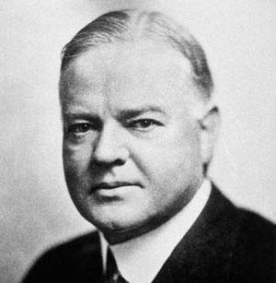
Herbert Hoover – President of the USA 1929 - 1932

- Pinned hopes on a ‘Voluntarist Approach’ to alleviate the problems of the economic crisis
- Set up The Reconstruction Finance Corporation
- Heavy-handed control of protestors

